AWS Serverless

1. Create a Lambda function: Start by creating a simple Lambda function in JavaScript. You can write a function that takes a string (The input string has to be passed within the event object to the lambda) and returns a new string with all the vowels removed. Test your function using the AWS Lambda console.

2.Trigger the Lambda function using API Gateway: Create an API Gateway endpoint that triggers your above Lambda function (The input string has to be passed as an API Request parameter, Make proper changes in the lambda handler to process the event from API Gateway). Use the API Gateway console to create a new POST API and define a resource and method for your endpoint.

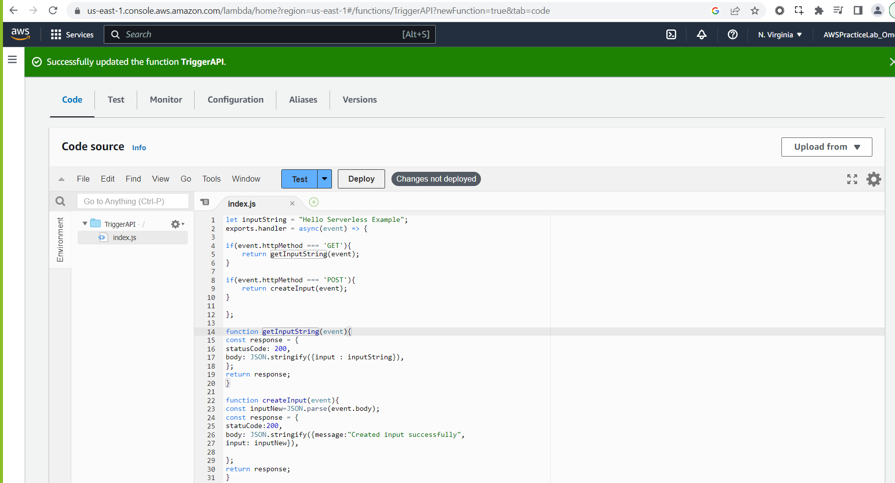

Just save it

Now go to search and type api

Select rest api

Create api

Create method-GET

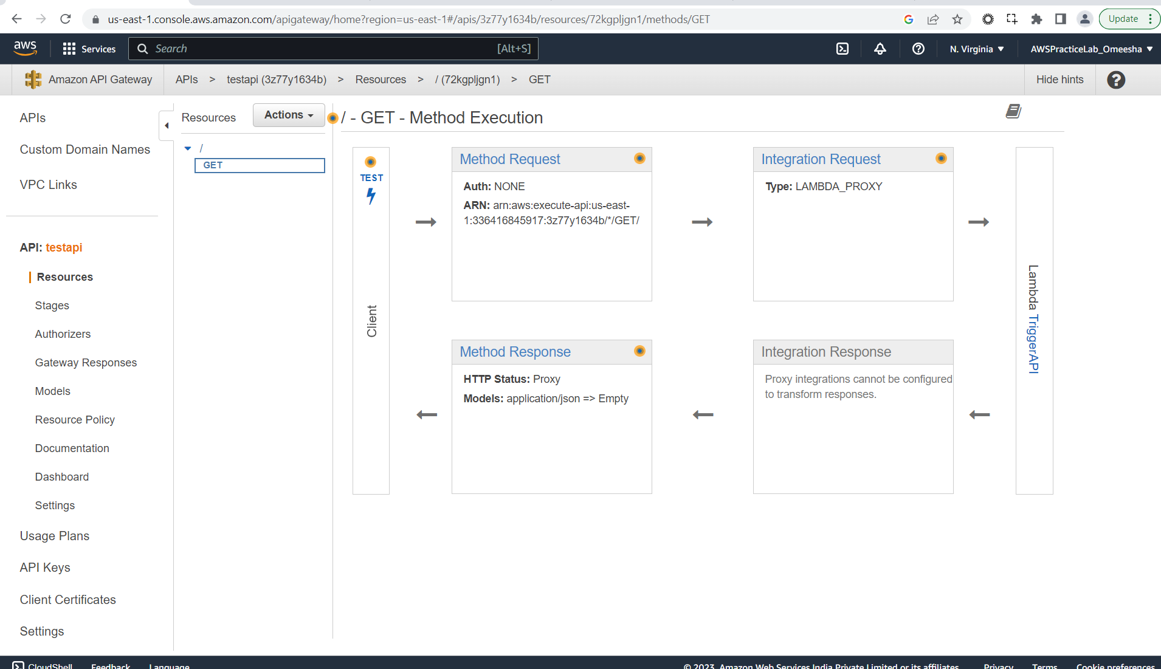click on actions>>deployAPI>>Provide a name

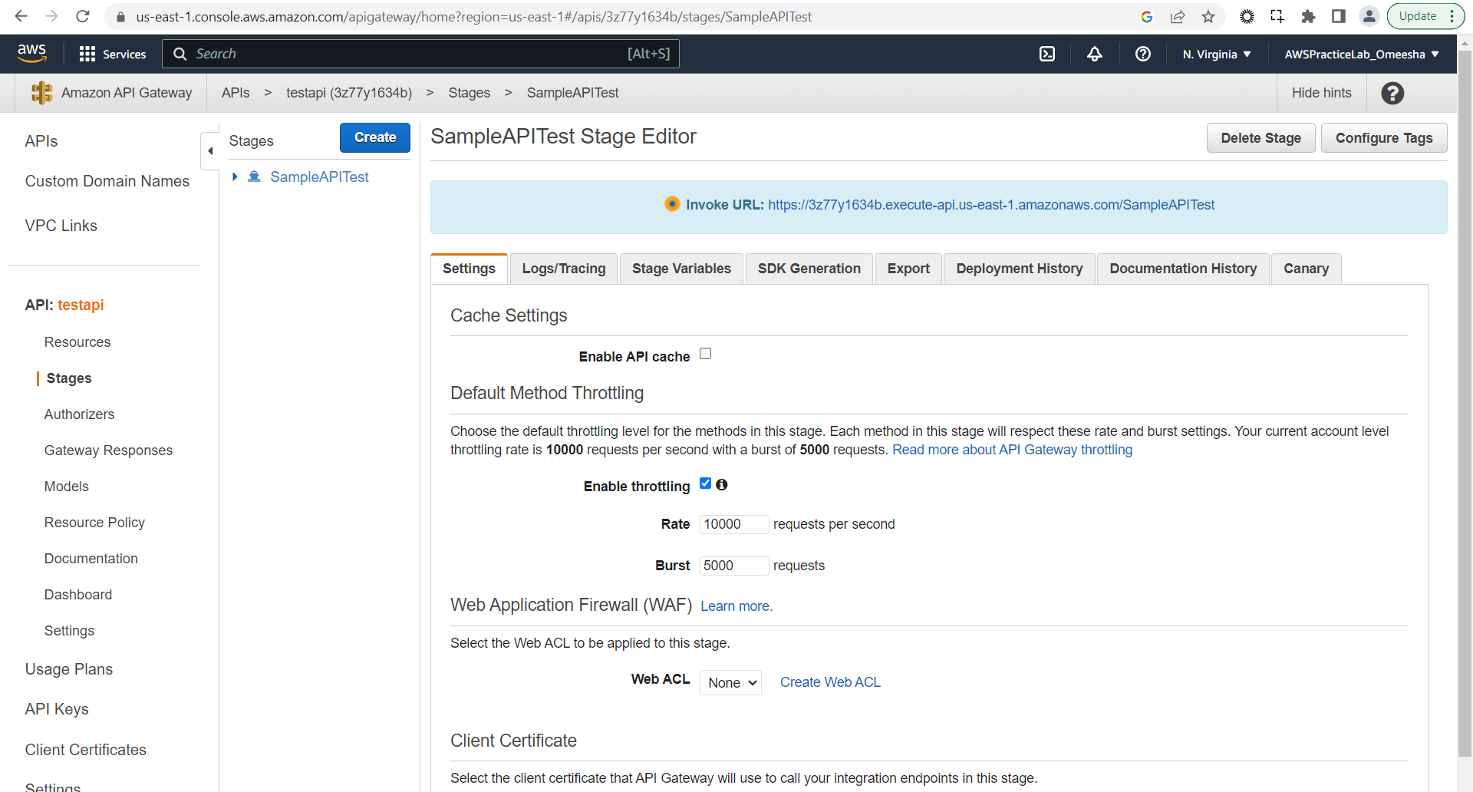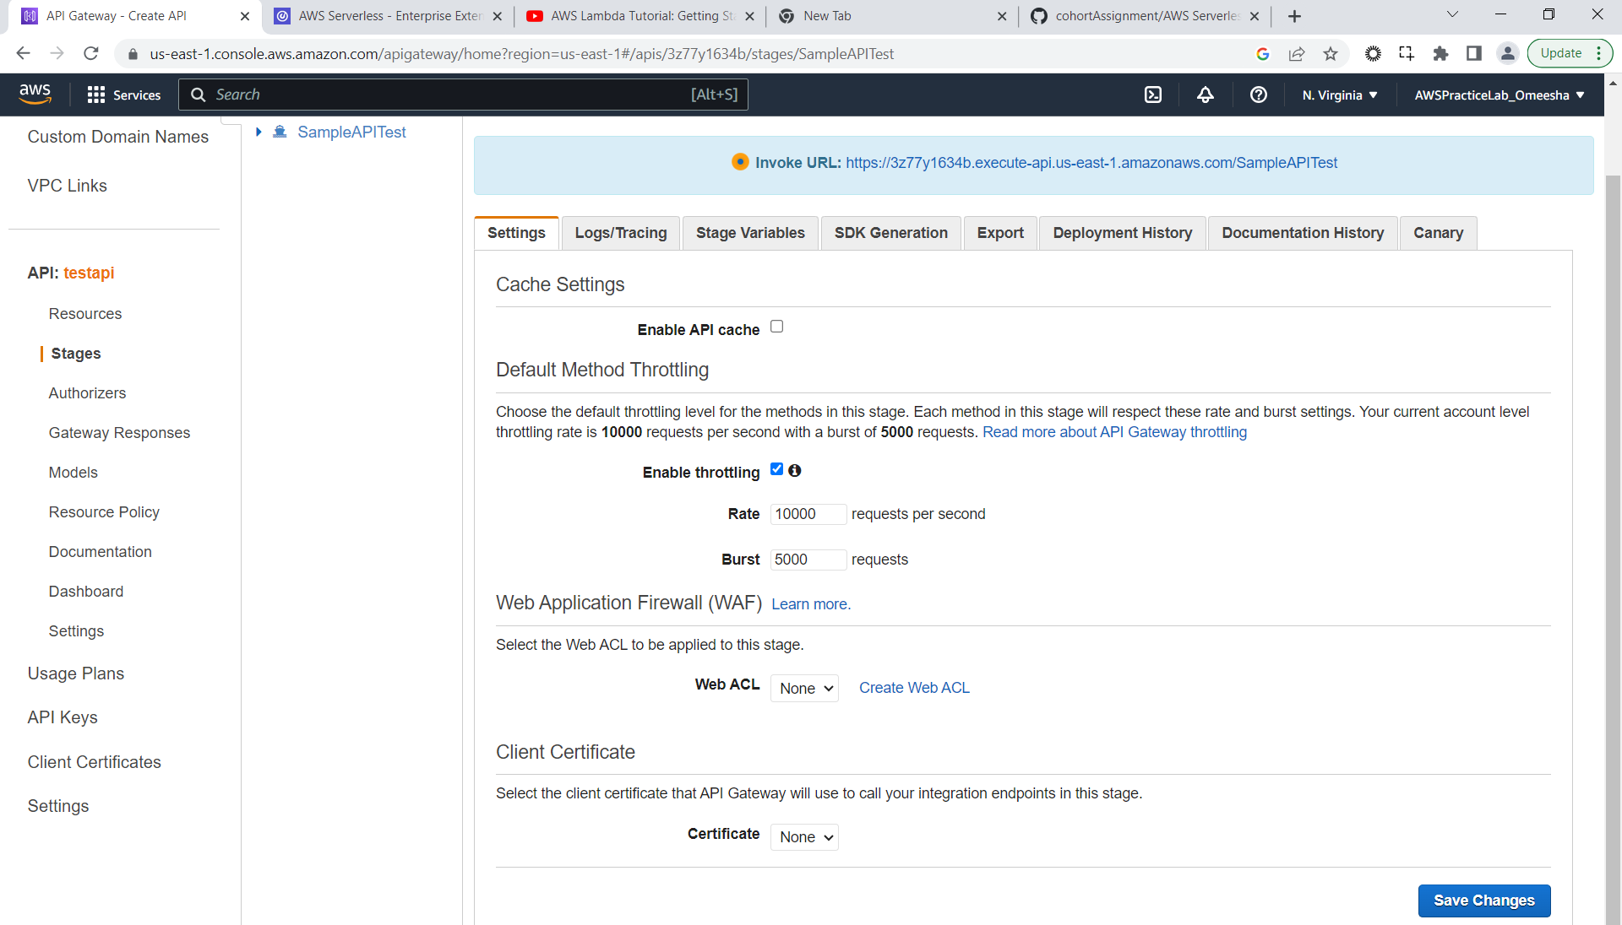**Invoke URL:** <https://3z77y1634b.execute-api.us-east-1.amazonaws.com/SampleAPITest/>

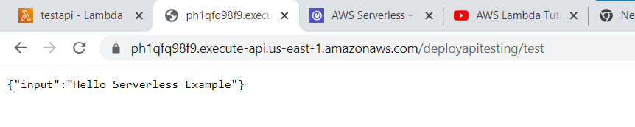

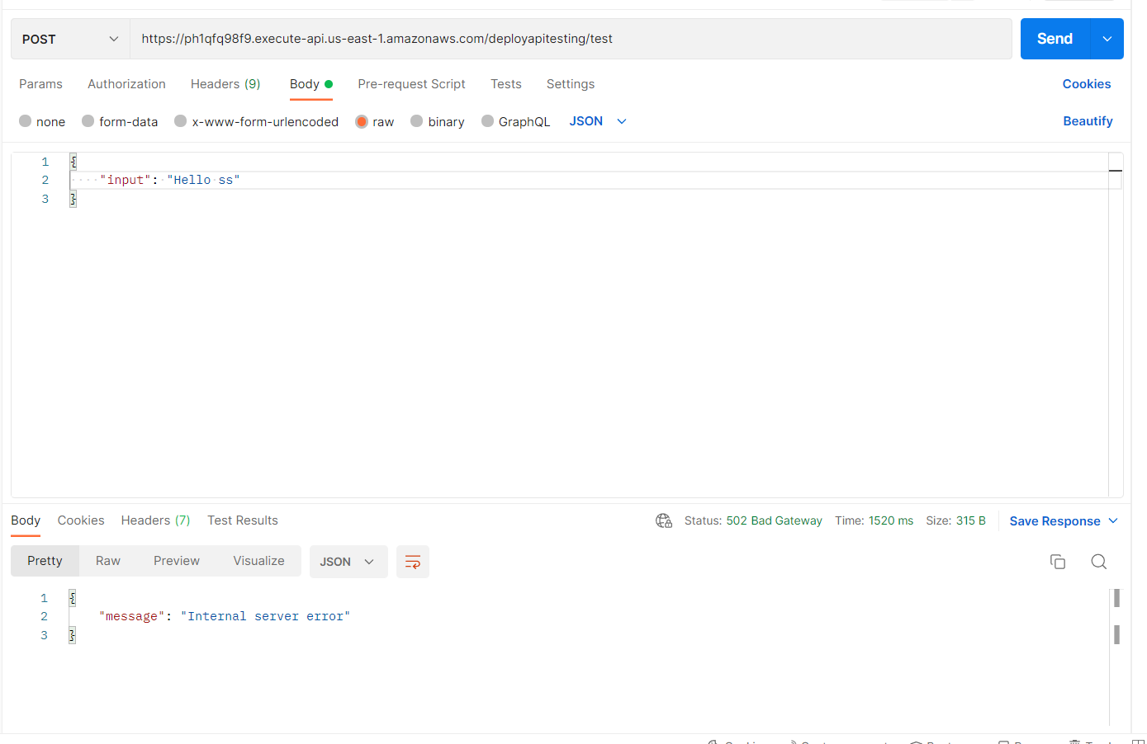Process is correct but not sure why getting 502 bad gateway error